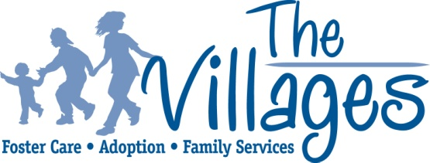
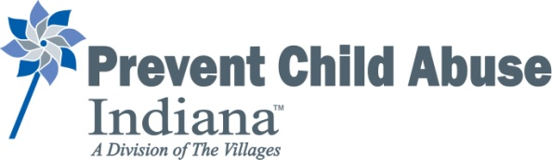

Prevent Child Abuse Indiana
Advisory Sub-Committee Meeting Minutes
October 12, 2023, | 3:00 PM

Members in attendance: Carolyn Clay-Hall; Rhonda Breman (chair), joined us at 3:30pm
Staff in attendance: Jeff Wittman (PCAIN Director); Shannon Schumacher (President & CEO, The Villages); Nancy Gwin (Senior Director of Prevention & Education); Kathy King (PCAIN Program Support Specialist)

Welcome, Introductions, and Call to Order Jeff Wittman, PCAIN Director
- Read through the CHARTER OF THE ADVISORY COMMITTEE that Rhonda drafted sentence by sentence. Once Rhonda joined us at 3:30pm she was updated on the changes made or added at that point.
- Rhonda brought out the PCAIN is a division of The Villages, not a program– that was a required term in the merger between The Villages & PCAIN in 2007. That may be a bit of semantics but thought it important to keep that in mind as we go through this process since PCAIN holds its own charter with PCA America as a Division of the Villages, not a program.
- The intent in forming Advisory Committee was to give the Committee governance responsibilities for PCAI similar to that of a board of directors – the only difference is the Committee reports to The Villages’ Board with recommendations for any actions and that Board holds the actual authority.
- It makes sense to give the Chair the responsibilities for the Committee with the Director (Jeff) serving in a similar role to the one Shannon is in with the Board.
- This sub-committee continued to read and make updates.

The PCAIN Advisory Sub-committee will share the Charter Draft with the full PCAIN Advisory Committee for review by email and then at the next meeting scheduled for November 7, 2023 in-person at The Villages Indianapolis office.

